1. Return the first name, last name and city of all customers who live in Canada. Order the results first by the last then by the first name.

**Answer:**

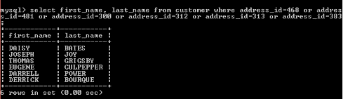

1. How many customers are from Brazil?

**Answer**

